Graphing Homework 3
Draw the appropriate graph in each of the boxes.
PPC | Unemployment  (=, <, >)   | 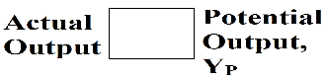  Business Cycle  (=, <, >) | AD/AS
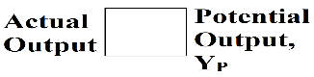
(=, <, >)
 |  | (=, <, >)
Potential Output/Long Run Equilibrium
Negative Output Gap
Positive Output Gap

